MAGOR

(Magor Action Group On Rail)

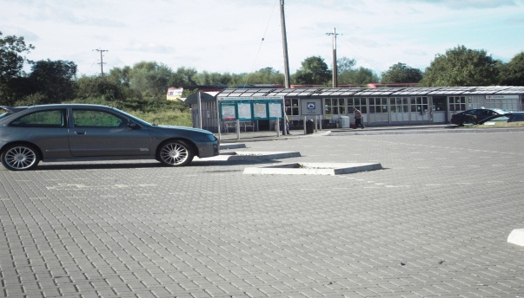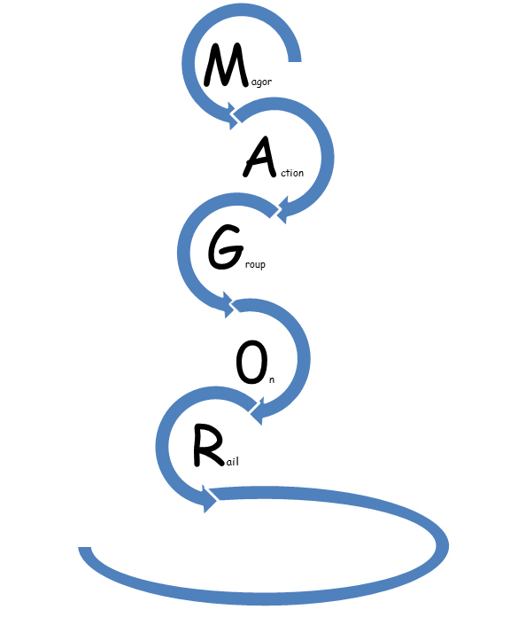

Our Mission

**We Aspire to Open the Gateway to the National Rail Network.**

**OUR OBJECTIVE**

**To Re-open a Railway Station to Serve the Community of Magor and Undy**

**OUR TARGET**

**To open St David’s Day 2018**

**UNIQUE SELLING POINT**

**The Station could be easily accessed by the entire 9000 population of the village, by foot or bicycle in less than 15 minutes.**

MEMBERS OF the Group

Laurence Hando Chairman

Frances Taylor Member

Jessica Crook Member

Ted Hand Member

Philip Inskip Member

Paul Turner Member

Rob Ollerton Member

Peter Wilson Member

Julie Wilson Member

Stuart Jones Member

Craig Davidson Member

Neeta Baicher Member

Louise Blackmore Member

Natalie Chamberlain Member

Keith Plow Member

Phil Walker Member

People iMPORTANT TO thE Group

Magor with Undy Council Community Council

Jessica Morden Member of Parliament

John Griffiths Constituency AM

Mohammad Asghar Regional AM

Jocelyn Davies Regional AM & AM Welsh Government Rail Group

Byron Davies AM Welsh Government Rail Group

Eluned Parrott AM Welsh Government Rail Group

Lyn Cadwallader MUSLA Community Centre

David Dovey (Chair Severnside & Lower Wye Joint Rail working group)  
 Monmouthshire County Council

Bryan Jones (Cabinet Member Transport) Monmouthshire County Council

Peter Fox (Leader – Cabinet) Monmouthshire County Council

Mark Youngman (Transport Policy Officer) Monmouthshire County Council

Kellie Beirne (Chief Officer for Regeneration and Culture)  
 Monmouthshire County Council

George Ashworth (Planning Officer) Monmouthshire County Council

Richard Cope (Passenger Transport Unit Manager)  
 Monmouthshire County Council

Mark Langman Network Rail

Michael Vaughan Arriva Trains Wales

John Pockett First Great Western

Caldicot & Wentloog Land Drainage Board

Gwent Wildlife Trust Tom Clarke

John Rogers Chair Railfuture Rail Campaigning Group

Welsh Assembly Government National

Residents of Magor and Undy Individuals / Unrepresented

Constitution

1. The Name of the Group
   1. The group shall be called the Magor Action Group On Rail (MAGOR)
2. Independent
   1. The group shall be and act in a way that is independent of political parties, trade unions, industry and railway companies and organisations. This shall not preclude individuals from these organisations being members of the Group or Committees.
3. Aims
   1. To work towards the provision of a station and rail services to serve the residents and those who travel to the Magor & Undy area.
   2. To represent the interests of users and potential users of rail (including light rail or tram) services in the area and aim to minimise the impact on any people who may be adversely affected.
   3. To raise awareness, encourage and promote the use of rail travel for residents, visitors, business users and tourists, including supporting tourism/leisure, community development projects and local businesses; therefore enabling local communities to increase their economic, social and environmental welfare.
   4. To foster and encourage sustainable transport and work towards maximising transport integration with the rail services for the Magor & Undy area.
   5. To seek to build and maintain good working relationships with the rail industry companies, the Welsh Government, the South East Wales Transport Consortium, County and Local councils and other stakeholders as necessary.
   6. To liaise, work with, or form partnerships with other user groups and organisations where this could be beneficial to the other aims of the Group.
   7. To increase community involvement with the railway, by bringing together a range of local people and organisations who share the above aims.
4. Membership
   1. Membership of the Group shall be open to any person or organisation that supports the aims of the Group, accept this constitution, and pays the appropriate subscription.
   2. Registered organisations shall notify the Secretary the name of the nominated representative.
   3. Members can be voted onto the Group at the Annual General Meeting or at Committee meetings.
   4. The Committee shall nominate a person or persons to act as Membership Secretary to maintain an up to date register of members of the Group.
   5. All data provided by members shall be used only for administration purposes by the Group, and will not be divulged to any other party. Should the Group be disbanded, such data will be destroyed
   6. The Committee shall have a right to exclude or suspend individuals or organisations from membership of the Group, subject to an appeal for reinstatement at the next Annual or Special General Meeting.
   7. Any serving officer can be removed following a vote of no confidence at a Special General Meeting.
   8. Other Committee members can be asked by the Officers to stand down for a given reason, again subject to an appeal for reinstatement at the next Annual or Special General Meeting.
5. Committee - NOT YET INVOKED; IN THE INTERIM THE AFFAIRS OF THE GROUP SHALL BE MANAGED BY AN ASSOCIATION OF INDIVIDUALS WISHING TO DEVELOP THE GROUP
   1. The affairs of the Group shall be directed by a Committee, elected at the Annual General Meeting of the Group, which shall meet as required and normally not less than four times a year
   2. The committee shall consist of no more than 9 members, including elected Officers.
   3. Election of Officers and members of the Committee shall be for 1 year.
   4. At the Annual General Meeting the Group shall elect from amongst its members a Chairperson, a Secretary, a Treasurer and such other Officers as the Group shall from time to time decide; and also agree the other members of the Committee.
   5. It is acceptable for an individual to hold more than one Officer’s post if this is found necessary
   6. The Chairperson and the Officers of the Group shall hold office until the conclusion of the elections at the next Annual General Meeting of the Group after their election; but shall be eligible for re-election.
   7. The committee may co-opt members to replace any who may resign during the course of the year.
   8. In addition to the members so elected the Committee shall have the power to co-opt further members as advisers for their expertise or interest from relevant outside organisations such as railway officials and representatives of local Councils, who may serve until the conclusion of the next Annual General Meeting after individual co-optation or any shorter period. Members co-opted as advisers under this provision shall not be entitled to vote at meetings of the Committee.
   9. The Committee may, at its discretion, invite a person of standing to occupy the position of president, this position being a nonvoting one, subject to re-invitation on an annual basis at the Annual General Meeting.
   10. The Committee may appoint such special sub-committees as may be deemed necessary and shall determine their terms of reference, powers, duration and composition. All acts and proceedings of such special sub-committees shall be reported back to the Committee as soon as possible
   11. Each sub-committee shall normally include at least one member of the main Committee.
   12. If the Committee by a simple majority decide at any time that it is necessary or advisable to dissolve the Group, it shall call a Special General Meeting at which all members of the Group have the power to vote.
   13. If such decision shall be confirmed by a two-thirds majority of those present and voting at such meeting the Committee shall have power to dissolve the Group and dispose of any assets held by or on behalf of the Group.
6. Meetings
   1. An Annual General Meeting of the Group shall be held at such time (not being more than 15 months after the holding of the preceding Annual General Meeting) and place as the Committee shall determine.
   2. At least 21 clear days' notice of the Annual General Meeting shall be given and publicised in a way agreed by the Committee in order to maximise as far as is practicable the notification of the meeting to members and the residents of the Magor & Undy areas.
   3. At the Annual General Meetings the business shall include:-
      1. the election of new members to the Group and ratification of those who have joined since the last Annual general meeting
      2. the election of Officers;
      3. the election of members to serve on the Committee;
      4. the appointment of an independent examiner of the accounts;
      5. the consideration of an annual report of the work done by or under the auspices of the Committee;
      6. the consideration of the examined accounts;
      7. review of the Constitution;
      8. the transaction of such other matters as may from time to time be necessary.
   4. A Special General Meeting; which shall have the powers of the Annual General Meeting, may be called either by the Committee, or at the request of not fewer than ten members who must give twenty days notice in writing to the Secretary of the Group
   5. Any alteration of this Constitution shall receive the approval of the majority of members of the Group for the time being present and voting at the Annual General Meeting or at a Special General Meeting specially called for the purpose.
   6. The quorum at a meeting of the Group or Committee shall consist of 4 members of the Committee, or such other number as the Group may in a General Meeting from time to time determine.
   7. The quorum at a meeting of a sub-committee shall consist of 3 members of the sub-committee or such other number as may be determined at a meeting of the main Committee.
   8. All questions arising at any meeting may be decided by a simple majority of those present and entitled to vote. In case of an equality of votes the chair of the meeting shall have a second or casting vote.
   9. There are no arrangements for Proxy or postal voting at any meeting.
   10. Minutes shall be kept by the Committee, and the secretary shall enter therein a record of all proceedings and resolutions.
   11. Meetings of the Committee shall be open to all members of the Group who may speak at these meetings and to the public who may also attend. Only members of the Committee shall be entitled to vote.
   12. Members of the public who are not members of the Group shall not have a right to speak at Committee meetings though as far as is reasonable the Chairperson at his/her discretion may invite them to do so.
7. Activities / Communication
   1. Individual members should only undertake activities or make statements on behalf of the Group as agreed at a Committee or General meeting and should not undertake any activities that are contrary to the aims of the Group.
   2. Communications with the media should be as agreed by the Committee. However to enable immediate and timely response the Chairperson, Secretary and others as nominated by the Committee have executive authority to make statements and provide information.
   3. The Chairperson of Sub committees shall normally be given authority to speak but limited to the specific subject of their Subcommittee.
   4. Details of communications not previously agreed by the Committee shall be advised to all members of the Committee at the earliest opportunity.
8. Website
   1. The Committee shall endeavour to create and maintain a website or to have a section of an existing appropriate website in order to improve general communication and to provide notification of meetings etc.
9. Newsletter / Journal
   1. The Committee shall consider the production and issue of a Newsletter / Journal
10. Finance
    1. The Treasurer shall keep proper accounts of the finances of the Group and report expenditure and income at each Committee meeting.
    2. The annual subscription for members of the Group shall be £0 - 0p (to be agreed) and will be used to run the administrative activities of the group
    3. Any monies raised by or on behalf of the Group shall be applied to further the aims of the Group and for no other purpose.
    4. Out of pocket expenses incurred by Committee or other members shall not be reimbursed and shall remain the responsibility of the individual to fund.
    5. Once any money is raised on behalf of the group or subscriptions collected, a bank account shall be opened and operated in the name of the Group.
    6. The signing of cheques or authorisation to incur expenditure on behalf of the Group shall require at least two signatories of Committee members of whom the Treasurer shall normally be one unless specific circumstances preclude this.
    7. The Committee shall authorise in writing at least three members of the Committee as authorised to sign cheques or authorise expenditure on behalf of the Group.
    8. The accounts shall be examined at least once a year by the independent examiner appointed at the Annual General Meeting.
    9. A statement of the accounts for the last financial year shall be submitted by the Committee to the Annual General Meeting.
    10. If the Group is dissolved any assets remaining after the satisfaction of any proper debts and liabilities shall be offered to the local Community Council to dispose of as they consider appropriate.
11. CONSTITUTION RATIFIED BY ANNUAL GENERAL MEETING: 04/07/2013
    1. Chairperson –
    2. Secretary
    3. Treasurer
    4. Member
    5. Member
    6. Member
    7. Member
    8. Member

**Reasons to have a Magor with Undy “Walkway” Community Railway Station**

1. It will be easier for commuters to get to work. In Severnside 48% of people travel out of the area for work (Navigant consultants Severnside Total Place) For commuters and other passengers to Newport / Cardiff or the greater Bristol area a station at Magor with Undy provides an easier alternative for those who presently use the car for the journey, reducing the congestion on the M4 and the approaches to Cardiff. For those who use rail a station at Magor with Undy avoids the miles of car journey to the station at Severn Tunnel Junction reducing congestion on the B4245 and also reducing the parking problems in Rogiet. For commuters and other passengers to Newport / Cardiff driving the wrong way to Severn Tunnel Junction to catch the westbound service adds 33% to the journey distance to Newport and 15% to Cardiff that will be avoided by a station in Magor / Undy.
2. In order to meet the 2050 Transport requirements of a more than 50% reduction in carbon emissions from all transport there is a need to minimise the use of private cars and encourage travel by electric railway. The provision of a local station at Magor / Undy will promote rail travel and minimise car usage and helps address the problems of “Peak Oil” and Climate change.
3. The population of Magor /Undy is circa 8000+, all of whom would live within one mile of the station. This would enable and encourage more people to walk or cycle to the station to catch the train. This would further contribute to reducing carbon footprint by reducing existing and new customers having to take the car to drive to Severn Tunnel Junction.
4. The population of Magor / Undy will inevitably continue to grow and there is a need to create transport options and solutions which reduce congestion and carbon footprint rather than allowing the developments to create a further deterioration of these important issues.
5. It is generally accepted by businesses that a more successful transport policy is based on taking people to work compared with trying to take work to the people. The dedication in South Wales to the extension of Valley Line stations is based on this and a station serving Magor with Undy would contribute to this successful policy. With two major cities within twenty miles, providing easier access to the major employment opportunities will stimulate both the local and wider economic growth.
6. Local residents would support and use a station for Magor / Undy as evidenced by the repeated campaigns for the reopening of the station that have received so much support through the years by those living in the area.
7. A station would provide improved access to college and educational establishments such as the University of the West of England and Filton College.
8. For people without access to a car a local station providing access to the wider national rail network provides greater opportunity for mobility and social inclusion.
9. Monmouthshire in general and Magor / Undy in particular have many areas of historic interest and a station would encourage tourists into the area. For example, promotion of the many well-maintained footpaths and walks, the Magor Marsh and nearby access to the Wales coastal path would help boost the local economy. It would help enhance the reputation and create a positive image of Monmouthshire County Council as one of a pro-rail authority encouraging growth in the most sustainable way.
10. Being on a rail network improves the prospect for new businesses to locate into the immediate vicinity.
11. With electrification of the South Wales main line authorised, there is the opportunity to develop Magor with Undy Walkway station by linking in to the capital investment that will be required to re-align the rail infrastructure to meet the new railway operation. The land infrastructure exists to create a main road integrated transport solution. Any future large developments in Magor/Undy such as supermarkets / housing need to include the development of a station in their plans to minimise additional traffic ion the B4245 and the M4.
12. The number of passengers using rail is increasing at rate that is outstripping each subsequent growth assessment. The building of Bristol Parkway in the small village of Stoke Gifford in the early 1970’s; then opening of the station at Cwmbran twenty years after the building of the town itself are just two examples of the great success in investing in rail. More recently the reopening of the Ebbw Vale line to passengers has vastly exceeded all predictions in the number of people who would use the railway. The reopening of a station at Magor /Undy can add to this success story and be perfectly positioned should in the longer term any developments such as the Cardiff Metro or the Shoots Barrage transport proposals reach the area.
13. Integration with bus services
14. Contributing to improved community health by residents walking or cycling to the station.
15. Contribute to reducing the number of vehicles using the B4245 through Magor /Undy at present measured at 11,000 vehicles a day.
16. Put Magor /Undy on the rail map.

**S.W.O.T. Analysis: Magor with Undy Station**

|  |  |
| --- | --- |
| Strengths  Population.  Location to travel networks.  Commuter area for three cities.  Socio- economic status.  **Could be walked or cycled by the overwhelming majority of the population of the villages in a matter of minutes.**  **Busses can call without diversion.**  **Reduce the demand on the B4245.**  **Speed up journeys to work.**  **Reduce carbon footprint.**  **High Value for money based on Southampton University Research on Assessing new Local Stations** | Weaknesses  Raising the Capital.  Lack of Interest among MCC.  Not included in Local Deposit Plan.  Speed of existing Relief Lines. |
| Opportunities  Electrification of the Line.  Deteriorating road infrastructure.  Rising cost of fuel.  Integrated with the future development of the community centre (including disability discrimination act requirements).  Possible route for a future Severn Barrage. | Threats  Electrification of the line.  Political lack of will.  Economic factors / finance availability.  Perception Magor too close to existing stations.  Outside European Convergence zone.  Line curvature and gradient at preferred station site.  Land ownership.  Train Operating Company unwilling to  serve station on Relief lines  Stations or proposed station development on either side.  Opposition from Bus companies  Concern on Planning issues from MUSLA Community Centre.  Severn Tunnel Junction car park does not go ahead  Competing initiatives |

**Executive Summary**

The villages of Magor and Undy are located in the County of Monmouthshire, South Wales. The villages are joined together and can be regarded as one semi-urban location. They are situated approximately 25 miles from Cardiff the capital city of Wales, 25 miles from Bristol and 10 miles from Newport.

The villages are idyllic places to live and this has given rise to a rapid growth in population numbers, with the estimated figure standing at around 9000 residents. The last figures available from the National Census show the population at 2001 was 6072 (see Appendix A). If today’s estimates are correct, the population has increased by a third in just ten years to 9000. The area has become very affluent with home and car ownership being high (see Appendix A). To cater for the growth, there has been significant house building, with only minor developments of commerce and industry close by to cater for employment. Wales 1 is a new business park situated at the western edge of Magor, on Junction 23A of the M4. The park has a hotel and office complex. There is also a brewery at the location, which is the largest of its type in Europe. Situated approximately two miles to the south west of Magor is a major distribution centre and Llanwern steel works.

The close proximity of the M4 Motorway, make the villages a very convenient place to access the routes to anywhere in Wales, England and Scotland The main railway line skirts the southern edge of the villages. However, the nearest railway stations are: Severn Tunnel Junction, two miles to the east and Newport, ten miles to the west. Severn Tunnel Junction is served by stopping and interurban trains (services to South West and Southern England and local services to Gloucester). Newport is additionally served by intercity services to London and other major cities in England.

The two railway stations in the villages- Magor and Undy Halt were both closed as part of the Beeching Plan in 1964 (see Appendix B). The loss of the two stations meant that people have to travel by car or bus to join train services. The B4245 which runs through the centre of the villages is used by approximately 11,000 vehicles per day. The volume of traffic makes the journey to the railway stations difficult, particularly at peak times.

In the last decade the volume of rail journeys has increased by 40% nationally. Severn Tunnel Junction has seen the flow of passengers using the train services increase by 100% in the same period. Since 2007 there has been modernisation of the facilities at Severn tunnel Junction and an improved train service introduced. These have been in the main as a result of the efforts of STAG (Severn Tunnel Action Group) a pressure group formed to combat a series of cuts to the train service that was being planned for December 2006.

A lot of the increase in the volume of passengers at Severn Tunnel Junction is due to a surge in commuters using the station. The benefits of shorter journey times against car travel to the centres of Newport, Cardiff and Bristol. The comparative average peak journey times for train and car from Severn Tunnel Junction are: to Newport – by train 10 minutes, by car 30 minutes; to Cardiff 30 minutes, by car 60 minutes; to Bristol, by train 30 minutes, by train 60 minutes. Other factors are the high cost of parking in the city centres and Severn bridge tolls for journeys to England.

A significant number (believed to be about a quarter) of commuters using Severn Tunnel Junction originate from the villages of Magor and Undy where a lot of people have moved in over the last decade and have to travel to their places of work. The majority would be travelling to Bristol. There is reluctance by people to travel to a point and then go back on themselves to reach their destination and then pass where they live and have to return to it; on their return journey. Hence the majority of commuters to Newport and Cardiff have a tendency to drive.

The B4245 is an arterial route from Chepstow that serves the population of Caldicot, Portskewett, Rogiet, Undy, Magor and surrounding areas. The road is heavily congested at peak times in the morning and evening and extremely busy at all other times. There are planned housing developments at Undy and Portskewett which will only add to the volume of traffic using this road. The abandoning of the M4 relief road for the foreseeable future will also exacerbate the traffic situation in the coming years.

The dramatic growth in the population in Magor and Undy, the ever increasing need to commute to work, the lack of a solution to the congestion on the B4245, the need to reduce the carbon footprint, are all justifiable needs to open a station at Magor with Undy.

In an endeavour to secure the objective of a new station development for the communities of Magor and Undy, the action group MAGOR has been formed.

**Mile Posts**

Mile postMile%20post%20151Evaluation meeting for MAGOR May 2012

MAGOR formed June 2012

Monthly meetings of Initiation Group started June 2012

Preliminary Meeting with Community Council October 2012

Initial discussion Network Rail (Dylan Bowen) October 2012  
Need to come back to Network Rail with worked up business case

Obtain full Benefit Cost ratio / Value for Money evaluation for station at Magor / Undy from Southampton University November 2012

Discussion with Conservative Assembly Member and Chair of Business and Enterprise Committee (Nick Ramsey) November 2012

Discussion with Kellie Beirne (Chief Officer for Regeneration and Culture Monmouthshire County Council) November 2012

Meeting with local Member of Parliament (Jessica Morden) November 2012

Extend remit of Joint Rail Working Group to include Magor with Undy –  
Put to Group November 2012   
Joint Rail Working Group requires background history. Submitted January 2013   
Formalise extended Remit

Meeting with Liberal Democrat Regional Assembly Member and Welsh Government Rail Group Assembly Member (Eluned Parrott) November 2012 November 2012

Meeting with SUSTRANS (Lee Waters)   
Meeting with Assistant Director (Jane Lorimer) held November 2012

Request to Network Rail for passive provision under electrification  
Request made By Jessica Morden MP on behalf of MAGOR group November 2012

Meeting with Conservative Regional Assembly Member (Mohammad Asghar)   
 November 2012

Inclusion of Magor with Undy station in Revised Railfuture Development Plan including Magor West End & Undy Church Road Tram stops in proposed Metro   
 November 2012

Meeting with Labour Constituency Assembly Member (John Griffiths)   
 November 2012

Meeting with Plaid Cymru Regional Assembly Member and Welsh Government Rail Group Assembly Member (Jocelyn Davies) November 2012

Review of WELTag Transport Appraisal Guidelines for a “Walkway” Community Railway Station – request made by John Griffiths (AM) on behalf of MAGOR group  
 November 2012 November 2012

Household Survey forms awaited – requested by Eluned Parrott (AM) November 2012

Meeting with MUSLA re Community Centre (Lyn Cadwallader) December 2012

Discussion with First Great Western Train Operating Company (John Pockett)   
 December 2012 December 2012

Discussion with Arriva Trains Wales Train Operating Company (Michael Vaughan)  
 December 2012 November 2012

Presentation to Community Council of proposals / plan January 2013

Meeting with Conservative Welsh Government Rail Group Assembly Member   
(Byron Davies) January 2013

Responses to SEWTA Chepstow Corridor Consultation including aspiration for Magor with Undy station – Submitted from MAGOR group January 2013  
Submitted from Magor with Undy Community Council January 2013  
Submitted from Severnside / Lower Wye Joint Rail Working Group January 2013

Meeting with Welsh Government Public Transport Users Committee (Dan Butler)  
 January 2013 Booked for January 2013

Meeting with County Councillor Jessica Crook January 2013

Meeting with Gray Hill Surgery re land use / site and parking for new Magor Surgery (Julian Crowe Practice Manager) – Covered in correspondence January 2013

Review of 2011 Census – Monmouthshire County Council confirmed they will prepare and produce extract information January 2013  
Review of 2011 census Data – Awaiting extract

Statistical information of road use (B4245) obtained from Monmouthshire County Council January 2013

Market Research & Personal Travel Plans – still to be arranged  
SUSTRANS personal Travel Plans costing received from Socialdata January 2013

Discussion on possible timescales with Network Rail – raised with Mark Langman by Byron Davies (AM) at Enterprise and Business Committee meeting January 2013

Request to Department for Transport for passive provision under electrification  
Request made By Jessica Morden MP on behalf of MAGOR group January 2013

Articles on Magor / Undy Station in the “Villager”  
First Article published November 2012  
Second Article published February 2013  
Third Article

Meeting with interested Businesses:-   
Meeting with General Manager (Roger Goldsworthy) Hampton Hilton Hotel  
 January 2013  
Meting Magor Brewery – request submitted awaiting response January 2013  
Meeting Wilkinsons Distribution Centre Controller – request submitted awaiting response January 2013  
Meeting with Tesco Distribution Centre – Contact made with Jessica Churchill Just awaiting dates for meeting with from Depot Manager February 2013  
Meeting with all businesses within Magor / Undy –   
Initial 21 businesses visited February 2013

Contact with Mark Davies Network Rail Electrification Project Manager – confirmation request for passive provision passed to Design Team February 2013

Contact & confirmation from Dr Simon Blainey Southampton University to use and quote from Station Forecasting Thesis February 2013

Publicise proposal in Media –  
Meeting with Free Press / Argus (Mellissa Jones) February 2013  
Article in the Free press February 3013  
Second Article in the Free press MP & AMs support February 3013  
Article in the Chepstow and Caldicot News March 2013  
BBC Radio Interview Planned March / April 2013

Meeting with Passenger Focus (David Beer) Full details of MAGOR proposals forwarded to Passenger Focus following meeting February 2013

Meeting with Gwent Association of Voluntary Organisations – GAVO (Jane Shatford) February 2013

Initial response on WELTag Transport Appraisal Guidelines received from Welsh Government returned to John Griffiths (AM) for further consideration, in turn taken up with Carl Sargent / Welsh Government - awaiting further response   
 February 2012

Information for Department for Transport - Accessible Train Station – Design for Disabled People – A Code of Practice Obtained February 2013  
Meeting with Monmouthshire Disability Champion (Andrew James) February 2013  
English copy European Standard PRM TSI (2008/164/EC) (Persons with Reduced Mobility - Technical Specification of Interoperability) Obtained February 2013

Produce brochures / Flyers February 2013

Locally publicise- Letter Box Drop? March 2013

Meeting with Monmouthshire County Council Tourist Officers   
(Nicola Smith, Mark Lloyd) March 2013

Meeting with Monmouthshire County Council Transport Policy officer   
(Mark Youngman) March 2013

Presentation to MUSLA March 2013

Initial flagging up of intention to propose a station at Magor / Undy raised by Bryan Jones at March SEWTA Board meeting March 2013

**Public meeting – chaired by Lord German – attended by Jessica Morden MP  
Peter Fox Leader MCC, David Dovey Deputy Chair MCC, Bryan Jones Cabinet member Transport MCC, Mark Youngman Chair Rail Working Group SEWTA, Michael Vaughan Franchise Manager Arriva Trains Wales 14th March 2013**

Submit MAGOR proposal to Joint Rail Working Group – Agreement member of   
MAGOR to sit on Joint Rail Working Group and converse March 2013

MAGOR Proposal to be submitted to Monmouthshire County Council Cabinet from Joint Rail Working Group Planned April 2013

Proposal to be formally submitted by Monmouthshire County Council to SEWTA for consideration Planned April 2013

Contact interested parties from Public Meeting Planned April 2013

Formally constitute larger MAGOR Group Planned May 2013

Update electrification Passive Provision to Network Rail following advice from Mark Youngman Planned April 2013

Consultation response from MAGOR to SEWTA Rail Strategy 2013 Final Report  
 Awaiting Consultation response date 2013

Meeting with Monmouthshire County Council Cabinet member with Transport Portfolio (Bryan Jones)

Meeting with Labour Welsh Government Rail Group Assembly Member   
(Vaughan Gething) Awaiting date 2013

Attend briefing on Cardiff Metro by Mark Barry. Awaiting date 2013

Attend briefing on SEWTA Metro plus by Mark Youngman. Awaiting date 2013

Meeting with SEWTA Representatives at Board Meeting Planned for June 2013

Issue of Railfuture Development Plan (including Magor with Undy station) to all AMs, Welsh Government Rail group etc. Planned for Mid 2013

Meeting with Monmouthshire County Council Engagement and Partnership (Will McClean)

Meeting with Senior Rail Technical Advisor at Transport Scotland (David Prescott)

Meeting with Caldicot & Wentloog Levels Internal Drainage Board (admin@caldandwentidb.gov.uk)

Meeting with Gwent Wildlife Trust (Tom Clerk)

Community Council member(s) formal attachment to the “MAGOR” group

Meeting with the Highway Officers at Monmouthshire County Council

Meeting with Planning Officers at Monmouthshire County Council

Meeting /Discussion with SEWTA Travel Plan Coordinator – (Nicola Davies)

Meeting with Bidders for replacement Great Western Franchise

Meeting with Electricity Supply Company re overhead lines in area

Meeting / Involvement local school

Affiliation with Campaign for Better Transport

Meeting / Involvement with Monmouthshire County Council Community Climate Champions

Affiliation with national rail campaigning group Railfuture Cymru

Affiliation with SUSTRANS

Update meeting with Network Rail

Meeting with Commercial Bus Companies

Meetings with local residents close to site of proposed station

Entry in the Regional Transport Plan

Meeting with Welsh Government Rail Group

Entry in the National Transport Plan

**Loads to go in here**

Magor with Undy Walkway Community Railway Station opened 1 March 2018

Bristol Electric Services along Relief Lines serving Magor with Undy Walkway Community Railway Station 2018-2020

**Mile postMile%20post%20151**

**Proposed Siting of the New Station**

The former Magor Station was located at the west end of the Magor village. Undy Halt was located in the centre of the Undy village alongside the B4245 road. Both stations were fit for purpose from when they opened in the 19th century and probably up until they closed in 1964.

Neither site would be suitable for building a new station due to the constraints of the changed railway infrastructure that has taken place at both the former sites in the last fifty years. Furthermore, car parking facilities would also not be available at either of the former sites. Having given due consideration to these problems, we are proposing that the new station be built on the open land adjacent to the site of the proposed community centre site. This would create an opportunity for a simultaneous joint development incorporating the station as part of the community hall.

This development would be easily accessible on foot or bicycle give adequate parking provision, ease of access and egress for buses taxis etc. As both would be new builds, the most modern of disabled facilities, environmental requirements could be incorporated and developed to such a standard as to meet current and future legislation. With this innovative approach would result in the provision of two much needed facilities benefitting every member of the community.

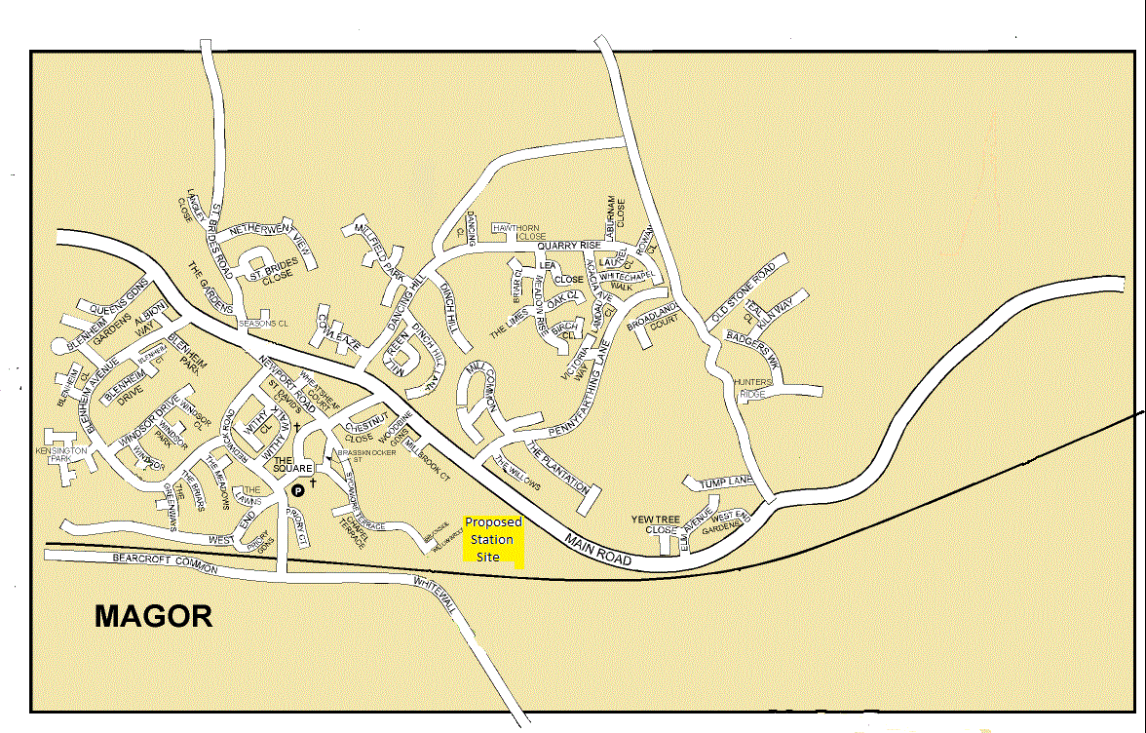

Appendix A

|  |  |
| --- | --- |
| **Population Census Magor with Undy 2001** |  |
| 2001 Population: All people | 6070 |
| 2001 Population: Males | 3020 |
| 2001 Population: Females | 3050 |
| All Households | 2306 |

|  |  |  |
| --- | --- | --- |
|  | Magor with Undy | Distance Travelled to Work |
| All People |  | 3227 |
| Works mainly at or from home |  | 320 |
| Less than 2km |  | 287 |
| 2km to less than 5km |  | 128 |
| 5km to less than 10km |  | 541 |
| 10km to less than 20km |  | 1126 |
| 20km to less than 30km |  | 473 |
| 30km to less than 40km |  | 85 |
| 40km to less than 60km |  | 48 |
| 60km and over |  | 118 |
| No fixed place of work |  | 98 |
| Working outside the UK |  | 3 |
| Working at offshore installation |  | 0 |

|  |  |  |
| --- | --- | --- |
| **Magor with Undy** | **Vehicle Ownership** |  |
| **All Households** | **Households** | **2307** |
| **No car or van** | **Households** | **171** |
| **1 car or van** | **Households** | **864** |
| **2 cars or vans** | **Households** | **1059** |
| **3 cars or vans** | **Households** | **163** |
| **4 or more cars or vans** | **Households** | **50** |
| **Total cars or vans** | **Vehicles** | **3689** |

|  |  |  |
| --- | --- | --- |
| **Magor with Undy** | **Age Profile** | **~~%~~** |
| **All People** | **6070** | **100** |
| **Aged 0 to10 years** | **1098** | **18.8** |
| **Aged 10 to 20 years** | **688** | **11.7** |
| **Aged 20 30 years** | **715** | **11.8** |
| **Aged 30 to 40 years** | **1250** | **20.6** |
| **Aged 40 to 50 years** | **902** | **14.9** |
| **Aged 50 to 60 years** | **698** | **11.7** |
| **Aged 60 to70 years** | **358** | **5.9** |
| **Aged 70 to 80 years** | **236** | **3.9** |
| **Aged 80 to 99 years** | **43** | **0.7** |

|  |  |
| --- | --- |
| Magor with Undy: Economic Activity |  |
| All People | 4325 |
| Economically active | 3312 |
| Economically active: Employee | 2815 |
| Economically active: Employee: Part-time | 592 |
| Economically active: Employee: Full-time | 2223 |
| Economically active: Self-employed with employees | 132 |
| Economically active: Self-employed with employees: Part-time | 16 |
| Economically active: Self-employed with employees: Full-time | 116 |
| Economically active: Self-employed without employees | 197 |
| Economically active: Self-employed without employees: Part-time | 65 |
| Economically active: Self-employed without employees: Full-time | 132 |
| Economically active: Unemployed | 73 |
| Economically active: Full-time Students | 95 |
| Economically inactive | 1013 |
| Economically inactive: Retired | 418 |
| Economically inactive: Student | 133 |
| Economically inactive: Looking after home / family | 246 |
| Economically inactive: Permanently sick / disabled | 147 |
| Economically inactive: Other | 69 |

|  |  |  |
| --- | --- | --- |
| Magor with Undy: Approximated Social Grade |  |  |
| All People Aged 16 and over in Households |  | 4559 |
| AB: Higher and intermediate managerial / administrative / professional | | 1614 |
| C1: Supervisory, clerical, junior managerial / administrative / professional | | 1433 |
| C2: Skilled manual workers |  | 635 |
| D: Semi-skilled and unskilled manual workers |  | 455 |
| E: On state benefit, unemployed, lowest grade workers |  | 422 |

© HMSO 2001 Census

Appendix B

To Live and Commute from Magor and Undy, you cannot miss the importance of our main B4245 thoroughfare. Without this lifeblood artery, the villages would not survive. But it wasn’t always that way!

In 1801 the population of Magor and Undy was about 475, with the villages served the local market/mill and farming community. Where horse drawn carts roamed the narrow lanes. A hundred years later the population had increased to about 878. Compare this with the explosion in the 20th century to our present level of about 9000 today in the 21st century. But how?

This growth was a result of the railways of the late 19th and early 20th centuries. The railways opened up the countryside and brought the farmers harvest to the markets in record time. In South Wales, the coal industry relied on the railways for transportation of the great quantities produced.

The opening of a station on Magor in 1850 was shortly after the line was opened. The station provided three sidings serving local farmers. With a Magor rail link and station wealth came to the area. In the 1920’s traffic on the line was so heavy that additional passing sidings were added to prevent slower trains delaying others. In the 1930’s a small halt and footbridge was constructed at Undy consisting of wooden platforms made from old sleepers. The main lines also included a pair of water troughs and large supply tank to quench the thirst of the locomotives. In 1941 this line was doubled to four running lines with the outer two being used for slow goods only, to serve the increasing war time coal traffic.

In the early 20th century, stations and lines began to close with the introduction of new bus services, the increased popularity of the car and the improvements in roads. Many rural stations were badly sited, well away from the towns and villages that they were designed to serve and this too led to a rapid decline in passenger numbers when more convenient forms of transport became available. The steady trickle of railway closures increased in the 1950’s turning into a torrent in the 1960’s with the rationalization of our railway network under the infamous Dr. Richard Beeching, the chairman of British Railways from 1961 – 1965. Magor and Undy Stations could not hold out and 1964 were closed to passengers.

Severn Tunnel Junction, also opened in 1850 as Rogiet Station, has fared better. First opened when Rogiet was no more than a church and farm, became a major goods yard, marshalling the coal from the pits of South Wales. From 1924 to 1966 Severn Tunnel Junction was the terminus of a car transport service through the tunnel to Pilning. As a result of reduced coal and industrial production from the mid-1980s from South Wales, and increases in fixed goods formations, Severn Tunnel Junction goods yard and locomotive depot were closed from 12 October 1987. The Station is still open today, but on reduced services, Severn Tunnel Junction has been the subject of much debate and local campaigning over its existence.